Microsoft Word Resources Add In

ECE 4318.01 Software Engineering

Group 1 – Demonstration

Group Leader

Michael Hicks

Members

Sam Bennett, William Lai, Isaac Elizarraz, Michael Bishara, Newton Le

Link to the video:

<https://youtu.be/KbawZEV5p9U>

Visual Studios Start:

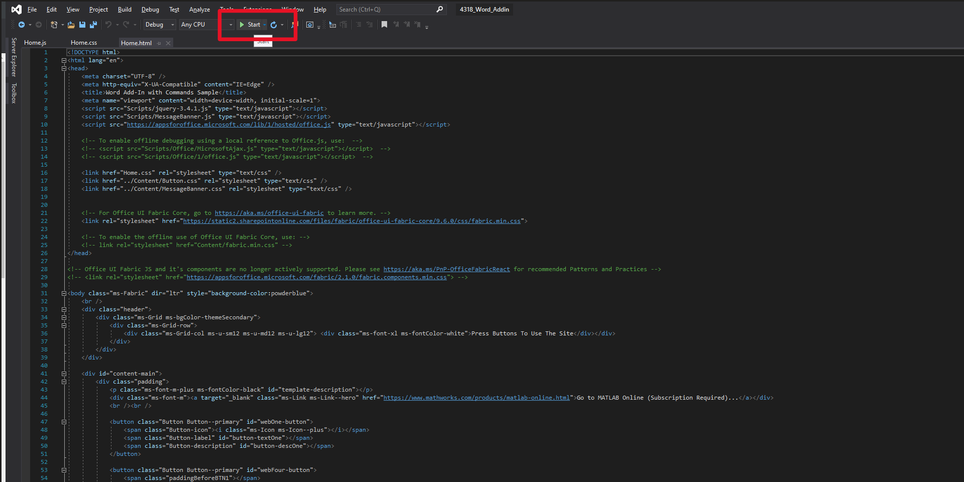  
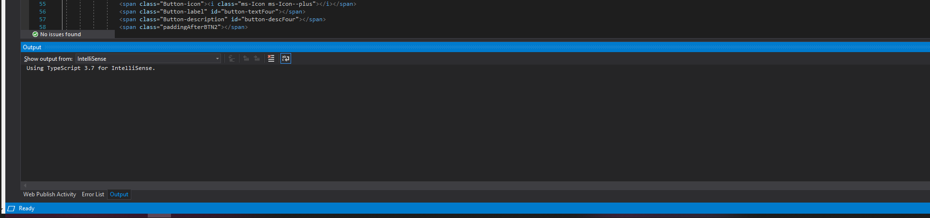

Debug Opened

